# Meeting 1:

Meeting Minutes

**Online Meeting** on November 12, 2022 – from 10AM to 11PM Attendees:

* Sreeja Reddy Chiligireddy
* Vaishnavi Gawni
* Anirudh Reddy Gade
* Sai Vamsi Krishna Kadiyala
* Vagdevi Gudapati
* Mukunda Priya Rachamalla
* Pentyala Meghana Chowdary
* Bandi Manvitha Chowdary Discussion:
  + We together discussed about the usecase diagrams for the phase-3.
  + We discussed about the unit tests and system tests.
  + Discussed about the functional and non-functional requirements for phase-3.
  + We discussed about the suggestions given by the opposite team and tried to implement them.

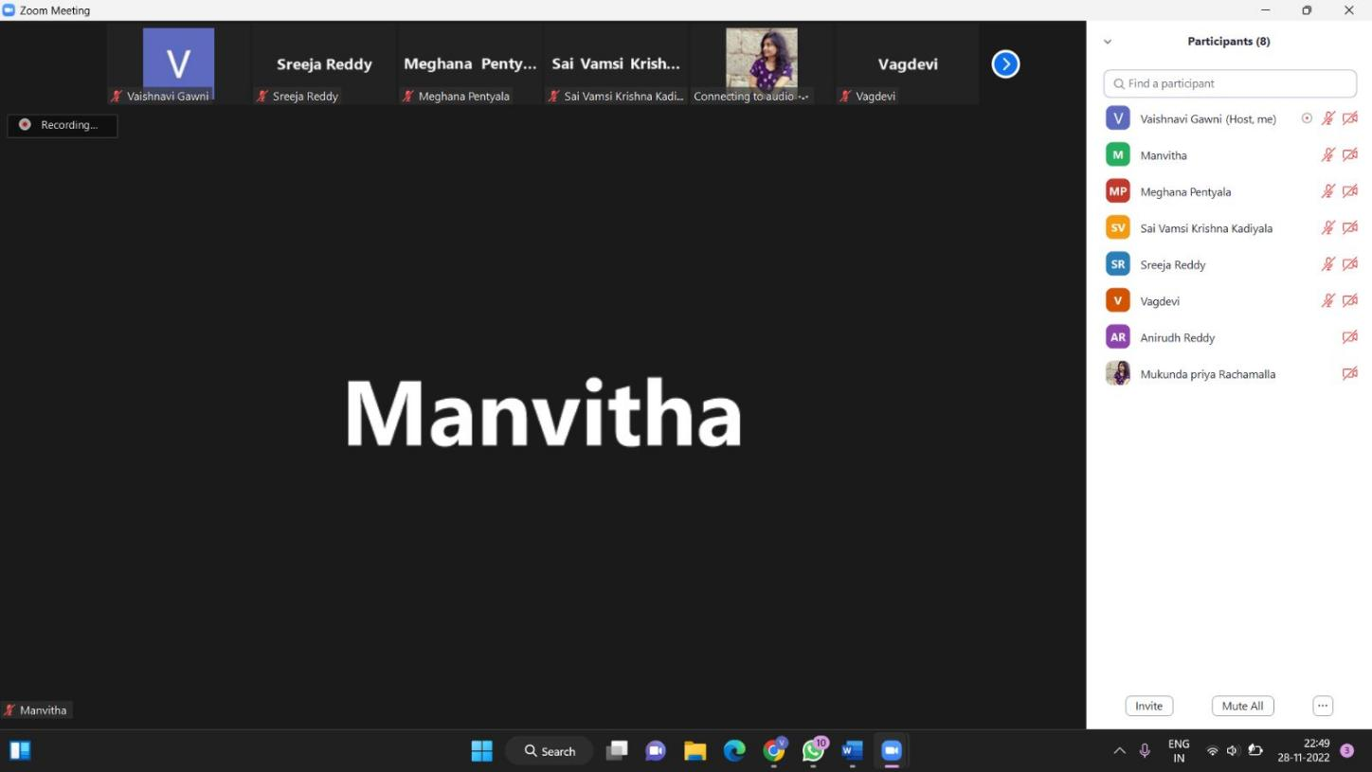

# Meeting 2:

We had a second **In-Person meeting** on November 25, 2022, from 3PM to 5PM.

Attendees:

* Sreeja Reddy Chiligireddy
* Vaishnavi Gawni
* Anirudh Reddy Gade
* Sai Vamsi Krishna Kadiyala
* Vagdevi Gudapati
* Mukunda Priya Rachamalla
* Pentyala Meghana Chowdary
* Bandi Manvitha Chowdary Discussion:
  + We discussed on the peer review.
  + Worked on sequence diagrams.
  + Worked on PPT for deliverable-5.